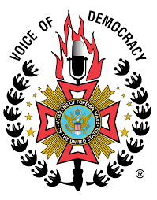The VACSI is a multi-donor facility established by eight development partners under an agreement with the: Austria, Denmark, Ireland, the United Kingdom, Netherlands, Norway, Sweden and the European Union. As development partners, the VACSI shares a vision with the government and the people of Africa of maintaining a corrupt-free Africa. Therefore, VACSI is committed to contributing to the fight against corruption by supporting CSOs and several state institutions whose mandate is to fight corruption.

The VACSI harmonizes development partner support to selected public institutions and civil society organizations to contribute to the promotion of democracy and good governance in Africa.

HUMAN RIGHTS AND CORRUPTION

The VACSI Working Group on Human Rights and Corruption serves as a platform for fostering discussions, exchanging knowledge, and sharing experiences among civil society, activists and academics working on human rights and corruption. Additionally, the Working Group provides a space for the coordination of advocacy efforts and the advancement of international and regional laws and policies in this regard.

**Working Group Co-Chairs:**

Thomas Breslin Patrick – president

Mayanja Abdul-Electoral observer